Financial Vulnerability across Canadian Provinces: Age, Human Capital and Family Background
Maryam Dilmaghani, Department of Economics, Sobey School of Business, Saint Mary’s University

Abstract
Using the General Social Survey of 2011, this paper investigates how financial vulnerability varies across Canadian provinces, for a sample of adults between 25 and 45 years of age. Financial vulnerability is defined as an indicator of the disproportionality of household consumption relative to its income. The results show that young adults residing in Nova Scotia (Newfoundland and Labrador) are statistically significantly more (less) vulnerable than the residents of other provinces, controlling for a wide array of characteristics, including income. Across the country, immigrants of these age cohorts are found more likely to be financially vulnerable than comparable non-immigrants. When controlling for immigration status, visible minorities did not statistically significantly differ from their Canadian-born counterparts.

I. Introduction
In recent years, various reports suggest that Canadian households, especially the younger ones, are over-extended in debt (Chawla & Uppal, 2012; Alexander & Jacobson, 2015). This trend has started in the 2000s (Faruqui, 2008), and is exacerbated by the low interest-rates of the post Great recession era (Walks, 2013). According to the Canadian General Social Survey (GSS-2011), about 14% of Canadians between 25 and 45 years of age were unable to pay at least one of their bills during the year 2010, while 18% reported being left with nothing after paying for their necessary expenses. Financial vulnerability of a household can be evaluated based on its ability to pay for its current expenses and service its debts, while maintaining an emergency fund. Inquiry into the spread of financial vulnerability among the younger cohorts is important for several reasons. First, in the post Great Recession era, job insecurity has become a ubiquitous concern. The absence of financial resilience makes the consequences of a job loss much direr for the individual and the economy as a whole (Zmitrowicz, & Khan, 2014). Second, it has been reported that a housing market correction is looming upon the Canadian economy (Macdonald, 2015). The vulnerability of these cohorts, more likely to be active in the housing market, is consequential for the entire financial sector of the country.
This paper, using the GSS-2011 data, identifies financially vulnerable individuals, based on the proportionality of their consumption to their income. A first look at the data shows significant variations across Canadian provinces, in the financial vulnerability of their residents, when the sample is restricted to younger cohorts. The present study aims at examining the robustness of this geographic pattern, while controlling for various correlates of financial vulnerability.

II. Data and Methodology
The analysis is conducted using the 2011 cycle of the Canadian General Social Survey, administered by Statistics Canada, and released in 2014. The dataset incorporates ample information on the respondents’ past and present labour market status, personal and household income, current family arrangement, as well as family background. Years of schooling, and highest degree attained by respondents, and their parents are recorded. The main variables used in this paper are listed and defined in Table 1, and the descriptive statistics are shown in Table 2. All reported estimates are computed using survey weights. The sample is restricted to the individuals between 25 and 45 years of age.

Table 1. Definitions of Main Variables
Variable | Definition
Failed to pay rent/mortgage | The GSS-2011 question is framed as: “At any time during the past 12 months, have you/has your household been unable to pay the scheduled rent or mortgage?”. The coverage of this question is all respondents. The valid response categories are Yes and No.
Failed to pay a utility bill | The GSS-2011 question is framed as: “At any time during the past 12 months, have you/has your household been unable to pay the scheduled utility bills, such as electricity, gas or water?”. The coverage of this question is all respondents. The valid response categories are Yes and No.
Failed to pay an instalment | The GSS-2011 question is framed as: “At any time during the past 12 months, have you/has your household been unable to pay the scheduled purchase instalments or other loan repayments?”. The coverage of this question is all respondents. The valid response categories are Yes and No.
Unable to save | The GSS-2011 question is framed as: “Usually, after essential expenses are paid, is there any money left that you and your spouse/partner can set aside for larger, unforeseen expenses or just savings?” The coverage of this question is all respondents. The valid response categories are Yes and No.
Financially vulnerable | A dichotomous variable taking the value of 1 for the respondents who have failed to pay at least one bill, or were unable to save.
Visible minority | A dichotomous variable taking the value of 1 for “persons, other than Aboriginal peoples, who are non-Caucasian in race or non-white in colour” (definition of Employment Equity Act of Canada); and 0 otherwise.
Allophone | A dichotomous variable taking the value of 1 for the respondents whose mother tongue(s) neither is (includes) French nor English; and 0 otherwise.
Immigrant | A dichotomous variable taking the value of 1 for “Not a Canadian-born”, where a Canadian born is defined as an individual either born in Canada or born outside Canada from Canadian parents; and 0 otherwise.
Locations | Canadian provinces: Newfoundland and Labrador (NL); Prince Edward Island (PEI); Nova Scotia (NS); New Brunswick (NB); Québec (QC); Ontario (ON); Manitoba (MN); Saskatchewan (SK); Alberta (AB); British Columbia (BC).
Note: See Statistics Canada, General Social Survey-2011; Guide, Available at: http://tinyurl.com/phylm2u

Table 2. Descriptive Statistics by Province
 | Financially Vulnerable (%) | Schooling (Years) | Bachelor’s (%) | Graduate Degree (%) | Immigrant (%)
NL | 10.2 | 12.8 | 15.2 | 4.7 | 2.8
PEI | 17.6 | 13.1 | 20.1 | 4.3 | 6.3
Nova Scotia | 20.8 | 12.9 | 21.3 | 5.1 | 8.3
NB | 18.6 | 12.8 | 19.8 | 5.1 | 4.7
Québec | 13.4 | 12.9 | 23.2 | 6.5 | 12.4
Ontario | 14.5 | 13.4 | 27.9 | 7.7 | 31.3
Manitoba | 12.0 | 13.0 | 20.7 | 4.5 | 19.2
Saskatchewan | 14.5 | 12.9 | 18.0 | 4.4 | 8.3
Alberta | 13.0 | 13.3 | 20.8 | 4.9 | 19.0
BC | 16.0 | 13.6 | 25.2 | 7.6 | 28.8
Female | 18.7 | 13.2 | 24.7 | 5.7 | 21.6
Male | 24.4 | 13.2 | 24.4 | 7.8 | 23.1
Sample | 21.9 | 13.2 | 24.5 | 6.7 | 22.3
Note: The data source is the General Social Survey of 2011, collected by Statistics Canada. Sample weights are applied.

There are four questions in the GSS that explicitly deal with financial resilience of the respondent.
First, the respondents were asked whether after meeting their financial obligations, they are left with any fund to save for emergency or larger expenses. Second, the respondents are asked whether in the past twelve months, they have failed to pay (i) their rent or mortgage; (ii) their utility bills; (iii) an instalment on a loan. To quantify the incidence of “financial vulnerability,” a dummy is created to take the value of one for individuals who responded affirmatively to at least one of these questions. Figures 1 to 4 depict the percentage of individuals who have failed to meet their financial obligations against those unable to save, by province of residence. As the figures illustrate, there are some non-negligible variations across Canadian provinces.
Figures
Figure 1. Failed to Pay Rent/Mortgage and Ability to Save
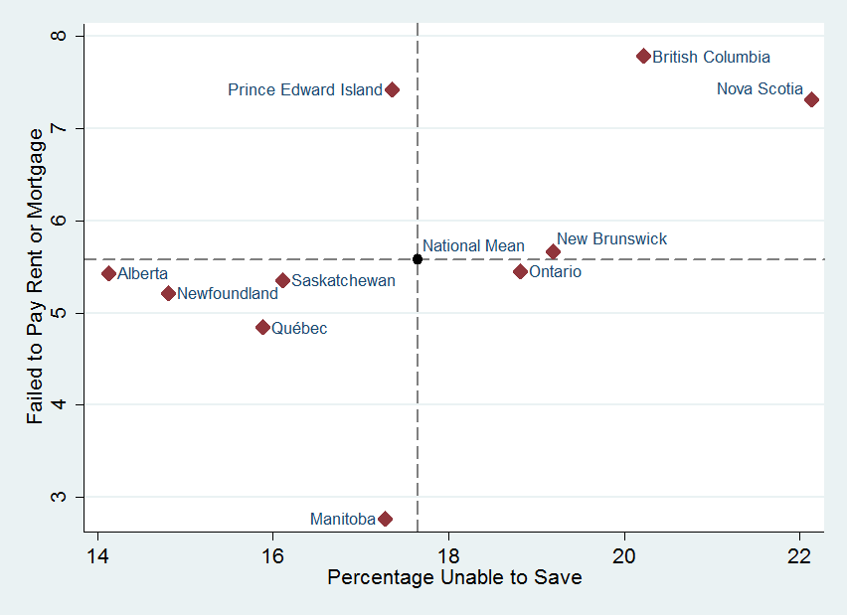
Figure 2. Failed to Pay Utility Bill and Ability to Save
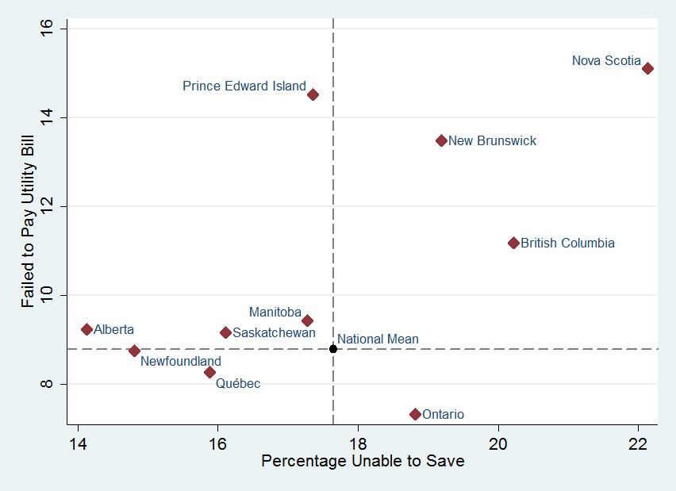
Figure 3. Failed to Pay Instalment on a Loan and Ability to Save
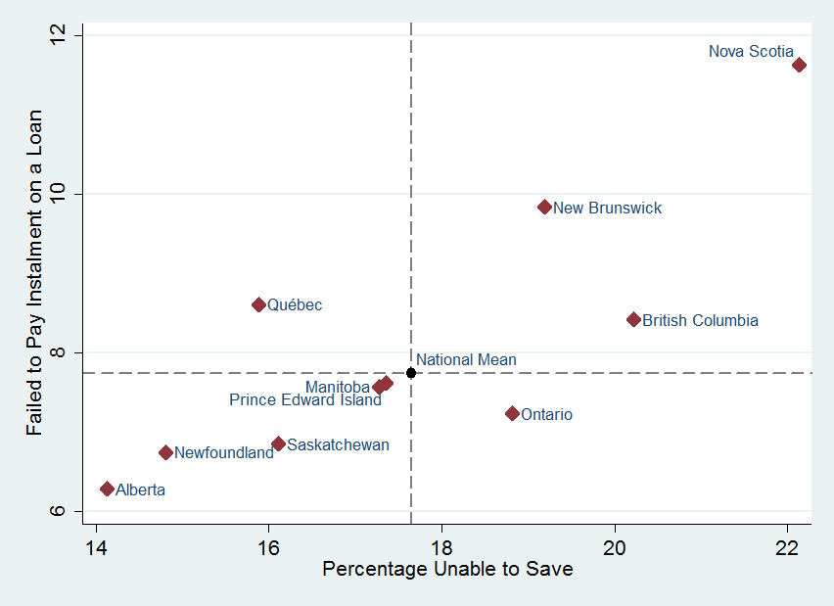
Figure 4. Failed to Pay at Least One Bill and Ability to Save
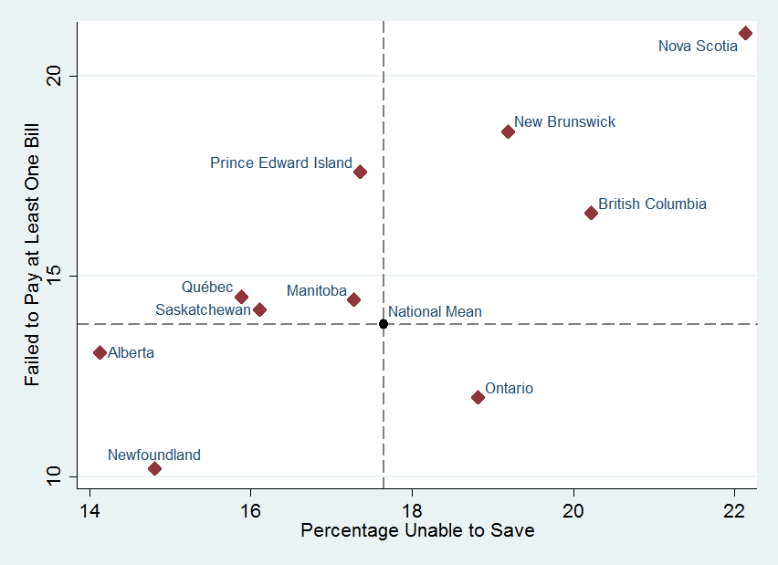

Nova Scotia, New Brunswick, and British Columbia seem to stand out in their share of vulnerable individuals. The aim of this paper is to see whether the cross-provincial differences subside after the inclusion of the controls. The estimations are made using Probit methodology. Heteroscedasticity robust standards errors and sample weights are employed. The generic formulation of the equation estimated in this paper is as follows:
$\operatorname{Pr}{(y=1|X)}= Φ\left(β_{0}+ Xβ+ε\right)$
where the left hand side of the equation is the likelihood of financial vulnerability. The Vector X incorporates socio-demographic controls, likely to determine the outcome.

III. Discussion of the Results
Table 3 reports a set of five stepwise regressions, in which explanatory variables are gradually added to the equation. Not all the controls are exposed in the table. The set of suppressed explanatory variables are exhaustively listed as note to the table. The associated marginal effects of the Probit estimations are reported in the table. The first equation, reported in Column (1), only incudes provincial dummies, leaving Ontario as the omitted category. This regression reveals that, when no characteristic is controlled for, the individuals between 25 to 45 years of age who reside in Nova Scotia are statistically significantly more likely than others to be financially vulnerable. Conversely, Newfoundland and Labrador is the only province with a statistically significant negative coefficient. The addition of controls, done in Column (2) onwards, impacts both the magnitude and the statistical significance of the provincial dummies. The natural logarithm of personal income, for which a large number of observations was missing, is only added in the last column.

Table 3. Stepwise Regressions, Likelihood of Financial Vulnerability
Controls | Zero order | Demographic | Human Capital | Background | Income
NL | -0.063 | -0.07 | -0.077 | -0.062 | -0.094
 | (0.028)** | (0.026)** | (0.025)** | (0.027)** | (0.025)**
PEI | 0.032 | 0.015 | -0.007 | 0.01 | 0.024
 | -0.041 | -0.039 | -0.037 | -0.039 | -0.043
Nova Scotia | 0.081 | 0.078 | 0.091 | 0.105 | 0.060
 | (0.034)** | (0.035)** | (0.036)** | (0.038)** | (0.038)*
New Brunswick | 0.051 | 0.05 | 0.036 | 0.062 | 0.018
 | -0.034 | -0.034 | -0.034 | -0.036 | -0.035
Québec | -0.007 | -0.008 | 0.002 | 0.029 | -0.024
 | -0.018 | -0.019 | -0.019 | -0.027 | -0.029
Manitoba | -0.007 | -0.037 | -0.031 | -0.024 | -0.024
 | -0.027 | -0.025 | -0.026 | -0.026 | -0.028
Saskatchewan | -0.022 | -0.05 | -0.055 | -0.051 | -0.033
 | -0.028 | -0.026 | (0.025)** | (0.025)** | -0.028
Alberta | -0.033 | -0.041 | -0.043 | -0.039 | -0.025
 | -0.019 | (0.019)** | (0.019)** | (0.018)** | -0.021
British Columbia | 0.039 | 0.046 | 0.048 | 0.047 | 0.035
 | -0.024 | -0.024 | (0.024)** | -0.024 | -0.028
Children | ----- | 0.055 | 0.041 | 0.046 | 0.051
 |  | (0.008)** | (0.008)** | (0.008)** | (0.010)**
Never married | ----- | -0.078 | -0.097 | -0.085 | -0.081
 |  | (0.018)** | (0.018)** | (0.019)** | (0.022)**
University degree | ----- | ----- | -0.095** | -0.095** | -0.074**
 |  |  | (0.019) | (0.019) | (0.021)
Number of employers | ----- | ----- | 0.034 | 0.037 | 0.036
 |  |  | (0.007)** | (0.007)** | (0.007)**
Growing up single- | ----- | ----- | ----- | -0.071 | -0.061
parent |  |  |  | (0.018)** | (0.019)**
Immigrant | ----- | ----- | ----- | 0.126** | 0.102**
 |  |  |  | (0.037) | (0.046)
Years since arrival | ----- | ----- | ----- | -0.003 | -0.001
 |  |  |  | (0.001)** | -0.000
Observations | 6,228 | 6,203 | 6,074 | 6,024 | 4,298
Note: Legend: Robust standard errors in parentheses; * Significant at 10%; ** significant at 5%. Suppressed controls in Column (2): Age, Age-squared; Marital Status, Household size, Number of Children; In Column (3): Work experience and its squared form; years of education; parents’ education, public servant; unionized worker; health occupation; part-time period; Column (4): Francophone; Allophone; Visible Minority; Foreign-born parents; Column (5): Natural logarithm of income.
According to the estimates reported in Column (5), which includes all the controls, two Atlantic Region provinces stand out. Newfoundland and Labrador is the only province with a statistically significant and negative coefficient, implying a lower likelihood of financial vulnerability compared to Ontario, all else held constant. On the other hand, Nova Scotia has the only statistically significant and positive coefficient. The regression reveals that individuals residing in Newfoundland and Labrador are 9% less likely than comparable Ontarians to be financially vulnerable, while the residents of Nova Scotia are about 6% more likely to experience the outcome, all else, including income, held constant.
Regarding the controls, having a university degree predicts 7% lower likelihood of financial vulnerability. Number of times an individual has changed employer is a positive predictor of financial vulnerability. Being married and number of children are positive predictors of financial vulnerability. Immigrants are found 10% more likely to be financially vulnerable. The rate of convergence to the Canadian-born, evident from the coefficient on “years since arrival,” appear to be slow. On the other hand, having foreign-born parents, being a visible minority, or being an Allophone (person whose mother tongue is neither English nor French), are not statistically significant predictors of financial vulnerability. Gender is also found not to be statistically significantly associated with the outcome. As shown in Column (5), growing up in a single-parent household, remarkably, predicts 7% higher likelihood of financial vulnerability, controlling for the respondents’ own current characteristics, including income.
It is interesting that two Atlantic Region provinces are found to have the highest and the lowest likelihood of financial vulnerability, among their residents between 25 and 45 years of age. The results on Newfoundland and Labrador is likely due to natural resource income. The financial vulnerability of Nova Scotia residents, on the other hand, is harder to explain, and a matter of concern. Atlantic Provinces as a whole, and especially Nova Scotia, have been experiencing outmigration of their youth and incoming immigrants (Akbari, 2013). The results reported here, indicating less than desirable economic conditions, point to the possibility of further outmigration, and human resource gap in this province.

References
Akbari, A. (2013). Immigrants in regional labour markets of host nations: Some evidence from Atlantic Canada. Springer Science & Business Media.
Alexander, C. R., & Jacobson, P. (2015). Mortgaged to the Hilt: Risks from the Distribution of Household Mortgage Debt. CD Howe Institute Commentary, No. 441. Available at: http://papers.ssrn.com/sol3/papers.cfm?abstract_id=2701923
Chawla, R. K., & Uppal, S. (2012). Household debt in Canada. Perspectives on labour and income, 24(2): 1-15.
Faruqui, U. (2008). Indebtedness and the Household Financial Health: An Examination of the Canadian Debt Service Ratio Distribution (No. 2008, 46). Bank of Canada Working paper.
Macdonald, D. (2015). The Young and the Leveraged: Assessing the Impact of a Housing Market Correction on Canada's Homeowners, Canadian Centre for Policy Alternatives, Available at: https://www.policyalternatives.ca/publications/reports/young-and-leveraged
Walks, A. (2013). Mapping the urban debtscape: The geography of household debt in Canadian cities. Urban Geography, 34(2), 153-187.
Zmitrowicz, K., & Khan, M. (2014). Beyond the Unemployment Rate: Assessing Canadian and US Labour Markets Since the Great Recession. Bank of Canada Review, 42-53.

The data source is the General Social Survey of 2011, collected by Statistics Canada. Newfoundland stands for the province Newfoundland and Labrador.

