Quebec’s Universal Childcare Policy: Immigrant Women’s Labour Supply and Childcare Usage

By: Habiba Khalifa

A Research Project Submitted to
Saint Mary’s University, Halifax, Nova Scotia
in Partial Fulfillment of the Requirements for
the Degree of Masters of Applied Economics

July, 2016 Halifax, Nova Scotia

© Habiba Khalifa, 2016

Approved: Dr. Martha MacDonald
Supervisor

Approved: Dr. Ather Akbari
Coordinator,
MAE Program

Date: July, 2016

Quebec’s Universal Childcare Policy: Immigrant Women’s Labour Supply and Childcare Usage

By: Habiba Khalifa

Abstract
The 1997 Quebec childcare policy is the first and only universal childcare program to be introduced in Canada. By using data from the National Longitudinal Survey of Children and Youth from Statistics Canada, this paper analyzes the effects of this policy on immigrant women’s labour supply and their childcare usage over the course of 8 different cycles: 1994-1995, 1996-1997, 1998-1999, 2000-2001, 2002-2003, 2004-20005, 2006-2007 and 2008-2009. A double difference-in-difference method is used to estimate the effects. The results show an increase in immigrant women’s labour force participation, affecting the lower educated mothers more than the higher educated ones. In the case of childcare usage, whilst the results show an overall increase in usage, the increase is largely for informal childcare. This research adds to the existing literature, as it is the first to analyze the effects of the policy on immigrants in particular; the assumption that immigrants behave in the same way as non-immigrants is not fully supported by the findings. This paper opens up a new line of inquiry regarding the impacts of the 1997 Quebec childcare policy.

July, 2016

Acknowledgements
I would first like to thank my advisor, Dr. Martha Macdonald, for her continuous and maximum support and patience. She guided me in the right direction and always had time for me.

I also highly appreciate the effort and time Dr. Atul Dar and Dr. Helene Zwick spent on reviewing the econometric model and results.

I would also like to thank my parents, Mohamed and Howaida for always being there for me, and of course my beautiful in-laws, Fouad and Manal.

Lastly, I would like to thank my husband, Ahmad Tawakol, without whom none of this would have been possible.

Table of Contents
Abstract i
Acknowledgements ii
Table of Contents iii
List of Tables and Figures iv
1. Introduction 1
2. Research on the 1997 Quebec Family Policy 3
2.1 Childcare Usage 6
2.2 Labour Supply 8
3. Research on Immigrant Women’s Labour Supply and Childcare Usage in Canada 11
3.1 Labour Supply 11
3.2 Childcare Usage 16
4. Methodology 18
4.1 Empirical Model 18
4.2 Data 20
5. Results and Discussion 24
5.1 Results for Childcare Usage 24
4.2 Results for Labour Supply 27
6. Conclusion 30
7. References 33
8. Tables and Figures 38

List of Tables and Figures
Table 1: Estimated marginal effects of Quebec’s childcare policy on immigrant mothers’ use of childcare compared to the Rest of Canada (p-value of bootstrapped standard errors) 37
Table 2: Estimated marginal effects of Quebec’s childcare policy on immigrant mothers’ use of daycare compared to the Rest of Canada (p-value of bootstrapped standard errors) 37
Table 3: Estimated marginal effects of Quebec’s childcare policy on immigrant mothers’ labour force participation compared to the Rest of Canada (p-value of bootstrapped standard errors) 38
Table 4: Estimated marginal effects of Quebec’s childcare policy on immigrant mothers’ hours worked compared to the Rest of Canada (p-value of bootstrapped standard errors) 38
Table 5A: Characteristics of immigrant mothers and children, Rest of Canada, cycle 1 to 8 39
Table 5B: Characteristics of immigrant mothers and children, Quebec, cycle 1 to 8 40

Figure 1: Percent subsidy by province 41
Figure 2: Regulated and subsidized spaces in Quebec 41
Figure 3: Factors associated with mothers’ entry or re-entry into the labour market during the 4 years following the birth of the child, Quebec, 1998-2002 42
Figure 4: Mothers’ rate of entry or re-entry into the labour market after the birth of the child, Quebec, 1998-2002 42

1. Introduction
In the matter of family policy, Quebec has always followed a different economic perspective than the rest of Canada. While the rest of Canada has mostly followed a non-interventionist model, which is characterized by ‘the virtual absence of any state measures for adjusting the work-family relationships’ (Tremblay, 2009, p. 275), Quebec is closer to a work-family balance model, where the state intervenes in making it possible to balance family with employment without replacing one for the other. Tremblay (2009) states that this model has the highest quality of public measures and assistance in the development of public childcare services, ‘excellent working-time arrangements, and paid and flexible parental leave’ (p. 271). This model is also argued to promote greater equality between men and women by encouraging a shared sense of family and work responsibilities (p. 271).
In 1997 the government of Quebec had a review process with three main goals; the first was ‘to ensure equity through universal support provided to families and increased assistance to low-income families,’ the second ‘to facilitate a balance of parental and work-related responsibilities’ and the third ‘to foster child development and promote equal opportunities’ (Tremblay, 2009, p. 271). This review resulted in Quebec’s Family Policy of 1997, and with it a major divide was created between childcare policies in Quebec and the rest of Canada. Quebec’s was the first universal childcare policy in Canada, and is still the only one.
There are debates about the merits of universal versus targeted childcare. Whilst targeted programs have lower costs, universal childcare has the advantage of reaching all children, including the disadvantaged. Targeted programs have a higher focus on quality as they concentrate their resources (money, staff and facilities) on a certain group (Barnett et al., 2004, p. 3). When publicly supported childcare becomes more widely available and the price declines, more women are able to afford it, which is argued to increase female labour force participation (Meyers, Marcia, Gornick & Ross, 1999, p. 121). In general, childcare policy has wide socio-economic impacts; it can affect gender equality, child development, women’s labour force participation and the general well-being of parents and children (Beaujot, Jiangqin & Ravanera, 2013, p. 235).
There have been several previous studies examining the effects of the 1997 Quebec Family Policy on labour supply, childcare usage and child outcomes for the full population. The aim of this paper is to extend this analysis by examining the long term effects of this universal policy on immigrants living in Quebec, compared to immigrants in the rest of Canada, where an income targeted childcare policy is in effect. The focus is on childcare usage and labour supply.
This is the first paper to assess the effects of Quebec’s 1997 Family Policy on immigrants. Such analysis is crucial, as immigration is identified as key to the growth of the Canadian economy (Ministry of Advanced Education and Labour Market Development, 2010). An estimated 260,000 people immigrated to Canada in 2014 (Statistics Canada, 2014). Immigrants account for about 65% of Canada’s net annual population growth, as Canada’s fertility rate is at a low of 1.6, much lower than the replacement rate of 2.1. Policymakers also view the aging of Canadian population as having consequences for future labor force and economic growth. By 2035 it is estimated that 25% of Canada’s population will be over the age of 65 (Conference Board of Canada, 2016, p.1). Immigrant girls and women comprise 21.2% of the total female population, or 3.5 million (National Household Survey, 2011), projected to increase to 5.8 million by 2031 (Malenfant, Eric, Lebel & Martel, 2010). It is thus important to understand how policy impacts immigrant women’s labour supply and use of childcare, as this affects the Canadian economy at large.
The second section of the paper outlines the Quebec policy and reviews the previous literature examining its impacts on childcare usage and mothers’ labour supply. Literature on work and childcare patterns of immigrant women is then reviewed in the third section to consider if the policy impacts are likely to differ for this group. The fourth section is the methodology section, which explains first the econometric model used and then the data set and the variables included in the analysis. The fifth section presents the results and discusses the findings. The sixth section concludes this paper and gives examples of further research that would extend our understanding of the issues raised in this study.

2. Research on the 1997 Quebec Family Policy
The Quebec Family Policy was a major policy change in the Canadian Province of Quebec in the late 1990s. This policy began in 1997 with full-time kindergarten for all children of 5 years of age plus a provision of childcare at ‘an out-of-pocket price’ of $5 per day to all children of 4 years of age. In 1998, the $5 policy was further extended to all children of 3 years of age, in 1999 to children of 2 years of age and in 2000 to all children less than the age of 2. It was later increased to $7 per day (Baker, Gruber & Milligan, 2008, p. 3). As of January 1, 2016, it has become more income-based. The basic fee is $7.55 per day, per child if the family’s net income is less than or equal to $50,545. For families with net income beyond $50,545, the rate increases with income to a maximum of $20.70 per day at $158,820. The additional payment declines to 50% for the second child and there is no additional payment for the third child (Finances Quebec, 2016, p. 1). The policy had three objectives: increase mothers’ labour force participation, develop a more balanced work-family model and provide equal opportunities for all children for early childhood education (LeFebvre, Merrigan & Desrosiers, 2011, p.1).
Baker et al. (2008) were among the first to evaluate the effects of the universal Quebec Family Policy Plan. The main data used in their analysis is from the National Longitudinal Survey of Children and Youth (NLSCY), which is a nationally representative panel survey on Canadian children. This survey is conducted bi-annually, and the data used in the experiment are the 1994-95, 1996-7, 1998-99, 2000-2001 and 2002-3 waves. The initial target age group for the survey was 0 to 11 year olds in 1994. This group is ‘followed longitudinally’ across the five waves. Only children from two-parent families are included in this study (p. 18).
The authors use a difference-in-difference model to compare the results in Quebec with the rest of Canada post-policy in Quebec. The period before the policy is denoted as wave 1 and wave 2 of the NLSCY, which is during the period 1994-95 to 1996-97. The period after the policy is denoted as wave 4 and wave 5 of the NLSCY, from 2000-2001 and 2002-3.
The authors used the equation below to account for outcome variables which include childcare use, labour supply of the mother and child outcomes.
The equation is:
- Outcome_{ipt} = Policy_{pt}⍺ + PROV_{p} β + Year_{t} φ + X_{ipt} λ + ε_{ipt}
where i indexes individuals, p indexes provinces, and t indexes years. The authors include year and province dummies, plus a set of control variables X_{ipt} to account for the parents’ characteristics (which includes education level, age group and immigration status) the size of the urban area, the number of siblings, and the age and sex of the child. The policy variable is a dummy variable for the eligibility of the child for the program, given the child is of appropriate age and resides in Quebec. The authors control for fixed effects for every province and year, therefore the effect of the childcare policy is identified by the change in Quebec in relation to the other provinces post-2000 relative to pre-1997 (p. 21).
The authors further evaluate the policy change by using a percent subsidy variable for the childcare use and labour supply regressions. These results are shown in the appendix as Figures 1 and 2 (Baker et al. 2005, p. 52, 51). Any changes or variations across provinces reflects only the differences in legislative environment, as the authors compute the subsidies for the same set of families across all provinces, as shown in Figure 1 (p. 52).
The authors exclude the third wave of the survey, i.e., 1998-99 wave, from the experiment and analysis because of the ‘lag in increasing the supply of subsidized spaces’ in the first years of the program, as seen in their Figure 2 (p. 51).
Other studies use different variations of this methodology. While Lefebvre et al. (2011) use the NLSCY dataset, Desrosiers, Helene, Gingras and Vachon (2004) use the Quebec Longitudinal Study of Child Development Survey to examine the different effects of the policy on childcare usage and labour supply. These studies and their results are examined below.

2.1 Childcare Usage
Childcare usage has increased extensively since the introduction of policy in 1997. Baker et al (2008) examine the size of the change and in what sectors the change was most evident. The authors sort the types of childcare used by the parents into (a) institutional care, (b) care in the home, (c) care outside the home (p. 20). The care that is subsidized by the Quebec Family Policy can be provided through early childhood centres (CPE’s) or through licensed home-based care givers, therefore the focus of the experiment is on institutional care and care outside of the home.
Their results show a 14.6% increase in the likelihood of a child being in childcare after the Quebec Family Policy change compared to the rest of Canada, and for every 10% increase in the subsidy rate to childcare, a 4.6% increase in utilization takes place. The authors calculate the elasticity of childcare use in relation to its price to be 0.58. This is shown in Figure 1 (p. 52), where a ‘trend break’ is clearly illustrated in the use of childcare in Quebec compared to the rest of Canada after the policy was instituted.
Baker et al. (2008) estimate changes in the various types of childcare arrangements. They find a large increase in institutional care, which is approximately equal to the increase in the overall use of childcare. Care shifted from unlicensed to licensed care providers. Both licensed relatives and non-relatives and licensed relatives are included in the ‘family-based care associated with CPE’s through the $5 per day program’ (p. 41).
Using the Quebec Longitudinal Study of Child Development Survey, Desrosiers et al. (2004, p. 8) study the usage of childcare and variations by sociodemographic characteristics, starting with children at the age of 1.5 years, as this is the average age at which mothers rejoin the labour market. They find that disadvantaged children were less likely to be in childcare, irrespective of their age.
Desrosiers et al. also find immigrant status to be a significant determinant of childcare usage. They estimate that young children with immigrant mothers, like children from single-parent households, were less likely to be in childcare. They argue that these mothers find it more difficult to return to the labour force after they give birth, perhaps because they have more traditional values when it comes to childcare.
Lefebvre at al. (2011) investigate the effect of the 1997 policy on hours children spend in formal daycare by differentiating the different age groups (p. 13). The authors use a double difference in difference estimation technique; they use Quebec as the treatment group and the rest of Canada (ROC) as the control group. They use the NLSCY to examine pre and post-policy; the post-policy starts from cycle 3 (1998-1999). Their model is a difference in difference specification, which is divided by period. The authors also differentiate by the mothers’ education levels using two categories - children of mothers with an education level equal to a secondary diploma or less and children of mothers with more than a secondary diploma.
They find that, for children under the age of 1, hours in daycare increased by 6.1 and 7.6 hours for cycles 4 and 5, showing the effect of the policy. For cycles 3 to 7 and ages 1 to 4 the effect is shown to be increasing greatly by 2.5, 5.9, 8.7, 10.4 and 10.7 hours. For children aged 5, most results are insignificant, as most children are by then enrolled in kindergarten and therefore are not affected by the policy. The overall effect is found to be higher for women in the higher education category, indicating that the effects of the policy are ‘sensitive’ to the mothers’ education level (p. 14).

2.2 Labour Supply
One of the main objectives of the policy is to increase mothers’ labour force activity. Impacts on both participation rates and hours worked have been examined in the research. LeFebvre and Merrigan (2008, p. 532) use annual data from Statistic’s Canada’s Survey of Labour and Income Dynamics (SLID), from 1993 to 2002 to assess the effects of the policy on participation and hours worked by mothers by their different education levels. The lowest education category is of mothers with a high school diploma or less education, and the highest is of mothers with more than a high school diploma. The sample consisted of all Canadian mothers with children aged 1 to 5. Using a difference-in-difference model, from 1999 to 2002, they estimate that labour force participation increased for the more educated mothers by 6.5%, and for the less educated mothers by 7.3%. In 2002, the policy is estimated to have increased the participation rate of all mothers with at least one pre-school aged child by 13%, as this was the year the policy was fully implemented (p. 536).
The hours worked also increased. The authors estimate that the policy increased annual hours worked in 1999 by 84 hours while in 2002, as the number of subsidized spaces increased, the annual hours worked increased by 231 hours for all mothers. By 2002, the policy had increased annual hours worked by 22% (p. 540). For the higher educated mothers, annual hours worked increased by 114 hours, while for the lower educated mothers the increase was 133 hours. They conclude that the policy affects more educated mothers less because they already work more hours, and therefore they have a larger income effect (p. 543).
Baker et al. (2008) show the effects of the Quebec Family Policy on the labour supply of women in two-parent families. They find an increase in labour force participation by these women in Quebec in relation to the rest of Canada of 7.7% (14.5% of baseline participation) (p. 17).
The authors note that the effect of the program on childcare use is almost double than that on labour supply. They provide two explanations for this outcome: First, that women may be using childcare and not working, and second that the reporting by the women answering the NSLCY questions might have changed; women who previously used informal childcare may have reported that they did not use childcare, and when they shifted to formal childcare after the policy, they reported their care. There is a 12.5% increase in those who reported working with childcare and a 4.8% decrease in those who reported working with no childcare, resulting in a total of 7.7% increase in women’s work. Therefore, they conclude that the 4.8% represents a ‘shift from unreported informal care to more formal care,’ and not a net increase in the usage of childcare (Baker et al., 2008, p. 18).
Desrosiers et al (2004), examine the factors that affect mothers’ decision to enter or reenter the workforce after childbirth. The authors use a proportional hazards model where all independent variables are fixed (except for birth of a sibling) over time and therefore show the situation at the time of the child’s birth. Figure 3 in the tables and figures section shows their results (p. 5). A coefficient lower than 1 shows a slower entry into the labour force whilst a coefficient higher than 1 shows a faster entry into the labour force. The results show that mothers who worked before child birth were more likely to work in the four years after. Mothers with a post-secondary diploma were also more likely to join the workforce even if they had no prior experience. The authors explain this in terms of easier working conditions for mothers that are more suitable for raising a family, such as ‘job security, work schedules and organization’ (p. 5). Single mothers were also less likely to enter the workforce after childbirth. This is possibly because they were in a different financial situation, where the single mothers are more likely to have been on social assistance for an extended period after childbirth (p. 5); they also have more responsibility and may be facing more anxiety or even depression. Immigration status also had a negative influence on the mothers’ return to work. This could be due to ‘immigrant mothers experiencing difficulties having their skills recognized or to different cultural values concerning child education’ (Desrosiers et al, 2004, p. 5).

3. Research on Immigrant Women’s Labour Supply and Childcare Usage in Canada

3.1 Labour Supply
The literature on the work patterns of immigrant women in Canada is relevant to the question of how immigrant mothers might respond to the introduction of universal, affordable childcare. There are two different views on the employment choices of immigrant women. The first views immigrant women as secondary or lower wage earners in the family. This is based on cultural and traditional expectations of gender roles and the main argument is that immigrant women join the labour market mainly to support their husbands’ ‘investment in local skills’ which decline in immigration (Adsera & Ferrer, p. 1). This was investigated by Worswick (1999) using an inter-temporal labour supply model, where the hours of work decisions of immigrant and non-immigrant families were compared using data from three Canadian population censuses, from 1981 to 1991. He evaluates the family investment hypothesis that ‘the immigrant wife responds by working longer hours so as to support family consumption and the husband’s labour market adjustment’ (p.152). His finding that immigrant wives work more hours in the years after migration than non-immigrant wives (1999, p. 168) supports the family investment hypothesis. He also finds that immigrant families are more likely to be ‘credit constrained’ than non-immigrant ones which further supports his view and gives more reason for immigrant wives to be spending longer working hours than non-immigrant ones.
However, other findings show the opposite, that immigrant women make labour supply decisions very similar to those of non-immigrant women. Blau, Kahn, Mariarty and Souza (2003) use samples from the Public Use Samples of the 1980 and 1990 Censuses to examine the assimilation patterns of U.S. immigrants (p. 430). They find that immigrants (men and women) work less than non-immigrants upon arrival to the United States, but soon reach the same level as non-immigrants. They also find that their results are not in line with the family investment hypothesis, as spouses seem to invest in their own human capital and labour market opportunities rather than their partners’ (p. 446).
Adsera and Ferrer (2014) examine the labour market advancement of immigrant women in Canada ‘through the changes in the task content of their occupations’ (p. 4). The authors use data from 1991 to 2006 from the Canadian Census to estimate their regression. The analysis relies on multiple cross-sectional data to separate the entry effects from the immigrant outcomes (p. 5). The outcomes they measure include labour force participation, wages and occupational skills. Adsera and Ferrer (2014) show that occupational skills track women’s assimilation in the labour market better than wages because some career positions that require higher skills are, to start off, lower paid, than some with lower skill requirements (p. 5). They demonstrate that Canadian immigrant women are not behaving as secondary workers in the family, based on the skills that are needed in their jobs, their wage advancement and their progressive increase in participation levels (p. 19). These results fit with the results of Blau et al. (2003) that examine the same patterns in the U.S.
As the education level of immigrant women increases, so does their skill level in the labour market, which has increased greatly over the past 20 years. This is partly due to the Canadian immigration policy changes during 1990s and early 2000s, which resulted in an increase in the percentage of immigrant women with a post-secondary education from 35% to 54% from 1991 to 2006 compared to an increase from 31% to 42% for non-immigrant women (Adsera & Ferrer, 2014, p. 9).
Despite the above changes, the gap in labour market participation between immigrant women and non-immigrant women living in Canada has not closed (Adsera & Ferrer, 2014, p. 19). Immigrant wives’ labour force participation rate is still lower than that of non-immigrant wives, at 76% and 88% respectively (Morisette and Galarneau, 2016, p. 1). Morissette and Galarneau use the Labour Force Survey and World Bank indicators from 2006 to 2014 to assess how much of this gap is due to socio-economic factors. Their results show that half of this difference is due to socio-economic characteristics (p. 2). Family size is a factor, with immigrant families being larger than the non-immigrants families. They report that as the family size increases, labour force participation declines (p. 2).
The source-country of the immigrant family is also an important factor. Immigrant wives mostly come from countries where women’s involvement in the workforce is lower than Canada’s. The female-to-male participation ratios for immigrants’ source countries in the early 2000s averaged around 0.60, compared to 0.84 in Canada. This negatively affects their labour force participation in Canada (Morissette & Galarneau, 2016, p. 2). Source-country labour force participation in Canada is studied in more detail by Frank and Hou (2015), using data from the 2006 to 2012 Labour Force Survey and the 1994 to 2007 World Values Survey. They use three different probit models to predict the likelihood of labour force participation by all working-age immigrant women (p. 12). Their results show that there is a high positive correlation between the source-country female labour force participation rate and immigrant women’s labour supply in Canada (p. 24).
Earning lower wage is another factor which Morissette and Galarneau (2016) examine to explain the gap between immigrant wives’ and non-immigrant wives’ labour force participation. Immigrant wives’ hourly wages were 20% lower than non-immigrant wives’ from 2006 to 2014 (Morissette & Galarneau, 2016, p. 3). The lower wages are correlated with lower participation rates, as lower wages make employment less attractive, therefore decreasing labour force participation (p. 3).
The lower wages are also partly attributed to gender-role attitudes, where women are discriminated against in their source country and therefore do not have the skills required to gain higher paying jobs in Canada. Frank and Hou (2015) find there is a positive relationship between gender-role attitudes in the source countries and immigrant women’s wages in Canada (p. 24). And, because most immigrant women come from Latin America, Africa and Asia, where there are low female labour force participation rates and also low scores in gender-role attitudes, wages are negatively affected (Frank & Hou, 2015, p. 13). There is also a positive correlation between female labour force participation rates in their source countries and wages earned by immigrant women in Canada (Frank & Hou, 2015, p. 24). If the source county has a high female labour force participation, women may have obtained more ‘specialized skills, labour market knowledge or other unobserved human capital that is useful in obtaining higher paying employment in the host country’ (Frank and Hou, 2015, p. 24).
In terms of the Quebec Family Policy, these factors suggest that labour supply of immigrant women will be affected differently than that of non-immigrants. While Canadian women’s labour supply increased due to the policy, the immigrants are further constrained by different cultural values, gender roles, expectation of lower wages and larger family sizes. Their labour supply is still expected to increase, however not as much as for non-immigrants.

3.2 Childcare Usage
The issue of childcare usage by immigrants has not been as extensively studied as labour force participation. But there are two standpoints apparent in the existing literature. The first is the traditional and cultural perspective, which emphasizes that immigrant women are less likely to use childcare than non-immigrants. Bushnik (2006) argues that immigrant parents have different views of childcare. She uses data from the NLSCY to report that children with parents who immigrated to Canada are less likely to be in care outside the home than children of non-immigrant parents, 20% and 34% respectively in 2002-2003 (Bushnik, 2006, p. 21). Moreover, 26% of children with immigrant parents were reported to be cared for at home by a relative, compared to 12% of children of non-immigrant parents. This may be explained by the increased likelihood of immigrant families to have adults other than their parents in the household or living nearby (p. 21). They further explain their findings using Leseman (2002), who argues most immigrants come from ‘non-industrialized agrarian societies’ where there are more traditional child rearing beliefs (p. 36).
Research has shown lower earnings and higher low-income rates among immigrants, which may have implications for childcare usage. For example, Picot Hou & Coulombe (2007), using data from the Longitudinal Administrative Database and the Longitudinal Immigration Database, find that low-income rates are higher for immigrants. Low-income rates for immigrants were 3.5 times that of the non-immigrants in 2002 and 3.2 times in 2004 (p. 4). This may in part explain the lower use of formal childcare, as the consumption choices of parents may be in part due to the cost of childcare, replacing it with one of the parents staying at home or using a relative. As Meyers et al. (1999) explain, as childcare costs increase, mothers will reduce participation, as the cost of childcare will in effect lower the mother’s net wage (p. 121).
Some literature downplays the role of immigration status in childcare usage, or makes a counter argument. Leseman (2002) states that the role of immigration is not as strong as the levels of household income, unemployment and education in determining childcare usage (p. 38). Other research suggests that immigrant women in fact use formal childcare more than non-immigrant ones. Santhiveeran (2010) uses the 2005 California Health Interview Survey (CHIS) to examine California’s children and their childcare usage. The study finds that immigrants are actually twice as likely to use formal childcare than non-immigrant families. These results show that, at least in California, there is a change of perception of childcare by immigrants and a greater acceptance of formal childcare in general (p. 156).
Furthermore, research finds that it is not just education, ethnicity or income that affect female labour force participation, but also childcare policies. Kesler (2006) shows that immigrant women in Sweden have higher probability of being employed than in Germany and Britain because of availability of childcare (p. 759).
Kesler’s findings suggest that the 1997 childcare policy in Quebec would be expected to increase female immigrants’ labour force participation and childcare usage, compared to the rest of Canada. With lower costs of childcare, immigrant women may also increase their usage of childcare as Picot et al. (2007) find that immigrants have higher low-income rates than non-immigrants, therefore by increasing their use of childcare with lower costs, they will be able to work more, and therefore increase their net wages. But there is still the factor of traditional and cultural values that immigrants have that may reduce the effect of lower costs of childcare on childcare usage, or encourage informal care arrangements.

4. Methodology

4.1 Empirical Model
The purpose of this paper is to measure the impact of the 1997 Quebec childcare policy on immigrant women’s labour supply and childcare usage (formal and informal). My hypotheses are:
- Immigrant mothers have similar labour supply responses as non-immigrants, and their labour force participation will increase with Quebec’s childcare policy.
- Childcare usage by immigrant mothers will also increase due to cheaper costs of childcare and an increase in labour force participation.
- Use of formal childcare (care in a daycare centre) will also increase due to lower costs of the universal child policy.
The econometric model used is based on the double difference-in-difference approach which is an econometric modelling strategy specifically used for estimating causal effects between two specified groups (the treatment and the control group) over a period of time with before and after effects of a treatment. This is the only model that could be used effectively to estimate the policy outcomes between Quebec and the rest of Canada. The treatment group is immigrants’ children in Quebec and the control group are immigrants’ children in the rest of Canada of the same age over the sixteen years of the NLSCY survey cycles. The pre-policy periods are cycles 1 and 2, while the post-policy period starts as of cycle 4, 2000-2001, as it was not until then that all children under aged 5 became eligible for the subsidized program; also in cycle 3 not all spaces were available, therefore it is not included.
The model used was initially presented by Francesconi and Van der Klaauw (2007) and later further developed by Lefebvre et al. (2011). It is a difference-in-difference specification as follows:
(2) Y_{it} = α + θQ_{it} + β₄D₄Q_{i4} + β₅D₅Q_{i5}+ β₆D₆Q_{i6} + β₇D₇Q_{i7} + β₈D₈Q_{i8} + X_{it} +ε_{it}
In the model above indexes i and t represent immigrant children and years respectively. Y_{it} represents the outcomes (the labour supply as represented by the immigrant women’s labour force participation or hours, the usage of immigrant childcare as represented by childcare use in the respective years). ε_{it} is the error term. Dummy variables D₄, D₅, D₆, D₇ and D₈ are included to take the value of 1 if the result is from cycle j and 0 if not, where j=4, 5, 6, 7, 8. Q_{it} is given as 1 when the immigrant child lives in Quebec and 0 if not. Together, Q_{it} and D_{t} represent post-policy periods in Quebec related only to immigrant children. X_{it} is a vector of socioeconomic control variables, which include the mother’s education, the child’s gender, the presence of siblings and the age of the child, as discussed above. Only the children of dual parents are included, as there are different, potentially conflicting programs specifically for single mothers that would complicate the results.
Firstly, the results for all children are examined, then they are divided by their mothers’ education, given the significant differences by education found in previous studies. The two categories used are mothers with a level of education equal to a secondary diploma or less and mothers with more than a secondary education.

4.2 Data
The main data set for this study, following Baker et al. (2008) and Lefebvre et al. (2011), is the NLSCY. The NLSCY is a nationally representative panel survey that studies Canadian children and their development and well-being from their birth to their early childhood. This sample survey collects information bi-annually on factors that influence the Canadian children’s social, emotional and behavioural development. The NLSCY’s target population includes all the non-institutionalized civilian population aged 0 to 11 at the time of the selection, in all of Canada’s ten provinces. This study uses eight cycles of this survey: 1994-1995, 1996-1997, 1998-1999, 2000-2001, 2002-2003, 2004-2005, 2006-2007 and 2008-2009 cycles. The survey is conducted longitudinally across the eight waves. An average of 2,000 children at each age per year are included.
The NLSCY has six main components. These include a household component providing information on demographics for all household members, an adult component providing information on the person most knowledgeable in the home and the spouse, a child component whose questions are answered by parents, a youth component whose questions are answered about themselves and, finally, direct assessments which are administered to the children and youth. The NLSCY not only tracks labour supply but also parents’ and teachers’ evaluations of the children’s developments in relation to test scores, behaviour and other indicators.
The effects of the policy are evaluated pre-policy and post-policy; cycle 1 and 2 are considered pre-policy while cycles 4 to 8 are considered post-policy. Given that the NLSCY stopped at cycle 8, this is the last one analyzed but 12 years post policy should be enough time to bring about significant and reliable results. The target sample is children ages 0 to 5, as this is the group affected by the childcare policy.
The sample used consists of only children of immigrant mothers. This is determined from the question ‘Are you now, or have you ever been a landed immigrant?’ which covers if the person was born outside of Canada or not a Canadian citizen by birth (a Canadian citizen by naturalization instead).
Following the research discussed above, the outcomes of interest are labour supply of mother and childcare usage. Two variables are used for labour supply. The first is participation, which is a binary variable given a value of 1 if the mother currently works and attends school or works only, and a value of 0 if she does not currently work. The second is the hours worked per week, which is a categorical variable. The number of hours worked by immigrant mothers are given values by NLSCY as: 1, 2, 3, 4, 5 and 6. Where 1 is a value for less than 10 hours of work, 2 for 10 to 19 hours, 3 for 20 to 29 hours, 4 for 20 to 39 hours, 5 for 40 to 49 hours and 6 for more than 50 hours.
Childcare usage is measured by two dummy variables: if the child uses childcare or not, and if they use care in a daycare centre (rather than less formal care), conditional of their use of childcare. The NLSCY has different components of childcare available: care in others’ home by a non-relative (regulated), care in others’ home by a non-relative (not regulated), care in someone else’s home by a relative, care in own home by sibling or relative, care in a daycare centre, own care or other arrangement. While the other component besides daycare that is considered as ‘formal childcare’ in the Quebec policy is regulated non-relative care, the numbers are nearly negligible and therefore we assume that the only type of formal childcare is care in a daycare centre. The childcare types that are covered by the policy are daycare centres and childcare centres (which are considered as one in the NLSCY database) and also licensed home-based childcares.
The control variables that are included are dummy variables for the mother’s education (which is divided into 4 categories by NLSCY; 1: less than secondary, 2: secondary school education, 3: beyond high school and 4: college/trade or university degree), the child’s gender, the presence of siblings and for the family type (where only the children of dual parents are included).

5. Results and Discussion

5.1 Results for Childcare Usage
First, we examine the effect of the childcare policy on immigrants’ childcare usage compared to the rest of Canada after the policy. Because this policy was implemented in stages and more spaces have been added gradually over the cycles, we divided our results based on the five different cycles post-policy. The first outcome variable is a dummy variable taking a value of 1 if the immigrant mother uses childcare. The double difference-in-difference model in equation (2) was used to obtain the results. The control variables used were mother’s education, the child’s gender, the presence of siblings and the age of the child. All results are computed as marginal effects of the policy on immigrant women and children in Quebec, compared to immigrant women and children in the rest of Canada after the policy change.
Table 1 shows the estimated marginal effects of Quebec’s childcare policy on childcare usage for immigrant mothers for survey cycles 4, 5, 6, 7 and 8 compared to the rest of Canada after the policy has taken effect. It also shows the results when the sample is split by the education of the mother (mothers with an education higher than a secondary diploma and mothers with an education less than or equal to a secondary diploma). The results show that childcare usage increased from cycle 4 to cycle 8, however, the only significant impacts are in cycles 4, 6 and 8, where childcare usage increased compared to the rest of Canada. From cycle 4 to cycle 8 there is an increase from 0.24 to 0.33, showing the positive effect of the childcare policy on immigrant mothers and a significant increase in childcare usage over time. This result is in support of our hypothesis that immigrant women’s childcare usage will increase with the change in policy.
Higher educated immigrant women have taken more advantage of the policy change than their less educated counterparts, as was also found by Lefebvre et al (2011). For higher educated women in cycles 4, 7 and 8 the usage marginal effects are all significant and positive, at 0.33, 0.31 and 0.42 respectively. This shows that the policy not only affects childcare usage positively but usage also increases gradually over time. The non-significant results of cycles 6 and 7 may be due to the 50-week maternity-parental leave federal program or the new Quebec parental leave program implemented in 2006 that more and more families are using (Lefebvre et al, 2011, p. 13). The increase in usage is also attributed to the increase in spaces available in daycare.
On the other hand, the results for less-educated immigrant women’s childcare usage are puzzling and differ from those for the general population found by Lefebvre et al (2011). The lack of significance may be due to the lower sample sizes as seen in the observations column. Only cycle 7 is significant for childcare usage for the less-educated mothers at p<0.001 and it is negative, meaning that the usage actually decreased. This finding does not support our second hypothesis that childcare usage by immigrant mothers will also increase due to cheaper costs of childcare and an increase in labour force participation. But it is consistent with the more traditional view of immigrant women’s use of childcare, at least for those with lower education.
The negative result for the less educated women in Table 1 in cycle 7 led us to examine childcare use further by estimating the marginal effects of Quebec’s childcare policy on the usage of daycare centres, as opposed to informal care. Table 2 shows all immigrant mothers' usage of daycare centres in Quebec compared to those in the rest of Canada, as well as the usage by immigrant mothers’ education levels as before. This sample is limited to only those mothers who use childcare. Almost all the results are insignificant, which could be because of the low sample sizes, or because use of daycare centres has not been affected by the change in policy. The only significant results are negative, meaning that usage of formal childcare has declined with the Quebec Family Policy. In the case of immigrant mothers with a lower education it is not only significantly negative but declines from -0.39 in cycle 4 to -0.47 in cycle 6. This means that not only is the formal child care usage by immigrant mothers negatively affected by the policy, but is also steadily decreasing. This is in direct contradiction with our third hypothesis that the use of formal childcare will increase due to lower costs of the universal child policy, and shows that while the use of childcare in general for immigrants appears to have increased, the use of formal care has decreased, as depicted by the negative results for the usage of daycare centres. These findings support both Bushnik (2006) and Leseman (2002) who argue that immigrant parents have different views of childcare than non-immigrant ones, more in line with traditional child-rearing beliefs which would favour informal care by relatives or community members.
The last panel of Tables 1and 2 gives results for all cycles combined. Childcare usage is significant and positive for all immigrant mothers and for mothers with higher education only, with effects equal to 0.23 and 0.31 respectively, meaning that the policy change positively affected and increased childcare usage for the above groups while all cycles are combined. Results are not significant for any of the daycare centre usage estimations.

4.2 Results for Labour Supply
The same econometric method and control variables were used to obtain the previous results were used to estimate the impact on labour force participation and hours worked by the immigrant mothers compared to immigrant mothers in the rest of Canada. As per the previous results, all results are calculated as marginal effects of the policy on immigrants in Quebec, compared to the rest of Canada after the policy change.
Labour force participation is a dummy variable with the value of 1 if the mother works and a value of 0 if the mother does not work. The number of hours worked is given by hours worked per week by immigrant mothers for the full sample. These results are shown in Tables 3 and 4.
Table 3 gives estimated marginal effects of Quebec’s childcare policy on all immigrant mothers’ labour force participation estimated for survey cycles 4, 5, 6, 7 and 8 compared to immigrant mothers’ labour force participation in the rest of Canada. It then shows the results split up by the education of the mother (mothers with an education higher than a secondary diploma and mothers with an education less than or equal to a secondary diploma). The results in Table 3 for all immigrant mothers combined are all significant and positive except for cycle 6. The effects also appear to be increasing in value with the lowest of 0.173 in cycle 4 and the highest value of 0.433 in cycle 7, while there is a slight downturn in cycle 8 of 0.221, possibly due to the decrease in the sample size in this cycle. The increase from cycles 4 to 7 reflects the increase in subsidized childcare spaces.
This is in line with our first hypothesis that immigrant women have similar labour force participation responses as non-immigrants, thus their participation will increase with Quebec’s childcare policy. Both studies by Baker et al. (2008) and Lefebvre et al. (2011) found that women increased their labour force participation with the Quebec policy change. Regarding the literature on immigrant women’s labour supply, our findings are in contradiction with the traditional view (Worswick, 1999) that immigrant women are secondary or lower wage earners in the family, restricting their participation. On the contrary, our results follow Adsera and Ferrer’s (2014) findings that immigrant women are not secondary workers, and in fact do look for their own best interest and labour market opportunities, not just those of their spouses (Blau et al, 2003). Thus, their participation is responsive to policy changes.
When the results are broken down by education categories, it seems the positive effects for the full sample in the first cycles are driven by the significant increase in participation for the less educated group, while it is the participation increase of the more educated group that matters in the later cycles. Both groups respond positively to the policy in terms of participation. The last panel of table 3 shows the estimated marginal effect on labour force participation in all cycles, post-policy. For immigrant mothers with a higher education level, the value is 0.19, while for those with a lower education, it is 0.36, which is about double the value. LeFebvre and Merrigan (2008) obtain similar results (immigrants and non-immigrants combined) and they attribute the lower effect of the policy for the higher educated group to a larger income effect, which may also explain the results for immigrant mothers (p. 543).
Table 4 shows the estimated results for the marginal effect of Quebec’s childcare policy on all immigrant mothers’ hours worked per week compared to all immigrant mothers’ hours worked per week in the rest of Canada. This is then split by the mothers’ education level, as above. Whilst most of the values are insignificant, those that are significant are all positive. It is also important to state that the data from NLSCY for mothers’ working hours included interval data and not continuous working hours, therefore if there are any small changes in the hours worked, it will not be detected. Note that in cycle 6, where the effects are significant for both lower and higher educated mothers, the size of the effect is greater for the former. This is perhaps because women with lower education are more likely to have lower skilled casual jobs where they can add hours more easily.

6. Conclusion
The 1997 Quebec childcare policy was a major policy change for Quebec. In this paper we examined the implications of this policy on immigrant mothers’ labour supply and childcare usage. Lefebvre et al.’s 2011 paper was followed as closely as possible, given the limitations presented, to be able to compare their results to that of immigrants’. A double difference-in-difference model was estimated for each of the outcomes. The results show significant effects of the policy on immigrant women and children in Quebec.
Firstly, compared to the rest of Canada, the policy change has substantially increased the number of immigrant mothers in Quebec who used childcare over the 12 years post-policy, but the effect varies by the women’s different education levels. While for higher educated women the usage increased, for lower educated women, the policy decreased their use of childcare. For formal childcare, estimated by the use of daycare centres, the results show that most immigrant mothers did not respond to the policy change, while lower educated mothers sometimes responded negatively, moving to more informal childcare. This may be due to lower prices of informal childcare (non-licensed) when formal childcare prices decline, or the care is provided by relatives, which would be at no cost at all.
The evidence obtained for immigrant mothers’ labour supply shows that immigrant mothers’ participation was affected positively by the change in policy, with the effect increasing over the years as the childcare system opened up more spaces for children. This response was greater for the lower educated than the higher educated mothers. Hours of work were not impacted significantly in most cases.
Previous studies have found the Quebec Family Policy Plan affected mothers positively by increasing their labour supply and increasing their usage of formal childcare (Baker et al., 2008). For immigrant mothers in Quebec the labour supply impact is similar, but the pattern of childcare use differs, especially for less educated mothers. The findings support a more traditionalist view towards childcare among less educated mothers, reflected in an overall increase in childcare but a decrease in formal care.
The policy had three objectives: increase the mothers’ labour force participation, develop a more balanced work-family model and provide equal opportunities for all children for early childhood education (Lefebvre et al, 2011, p.1). While the policy achieved its objective of increasing women’s labour force participation amongst immigrants, it has not been as successful in achieving equality among the children of Quebec in the case of their mothers’ childcare usage. The policy could therefore be better adapted to serve immigrants; for instance, a lower fee could be used for immigrants to increase their use of formal as opposed to informal childcare. It may seem that it can also be a matter of immigrant integration into the Canadian society; more informational programing could be directed to immigrants to educate them about the benefits of formal childcare. This is important as the proportion of preschool children that have immigrant parent grows.
This is the first study on the effects of the 1997 Quebec child policy on immigrants, although immigrants are a large portion of today’s Canadian society. Future research should further evaluate the effects of this policy on immigrant women and children. This should be done by including more variables to assess the outcomes. For labour supply it is best to also include weeks worked in the given year, and for childcare usage, it would be beneficial to also include the hours the children use childcare, as this would give a more precise estimate of the effect of the policy. It would also be interesting to estimate the effects of the policy on immigrants depending on their income and ethnicity, given the literature on the importance of source country participation and values.
The National Longitudinal Survey of Children and Youth has excellent information for research on the Quebec Family Policy, but there are limitations in the data that set us back. Many variables are suppressed by the NSLCY database, but the main issue was that the sample of immigrants was extremely low and this resulted in many insignificant estimates. It would also be more beneficial if the hours worked by immigrants were reported as continuous, rather than in intervals, as it would better capture the small changes, not differences in 10’s of hours. Future studies should explore different datasets, that might include more immigrants and more continuous rather than categorical data (such as for hours worked, education).

7. References
Adsera, A., & Ferrer, A. (2014). Labour market progression of Canadian immigrant women. Institute for the Study of Labour. 8407, 1-20. http://dx.doi.org/10.1016/j.labeco.2016.02.003
Baker, M., Gruber, J., & Milligan, K. (2008). Universal childcare, maternal labour supply, and family well being. Journal of Political Economy, 116(4), 709-745. http://dx.doi.org/10.1086/591908
Beaujot, R., Jiangqin Du, C., & Ravanera, Z. (2013). Family policies in Quebec and the rest of Canada: Implications for fertility, child-care, women's paid work, and child development indicators. Canadian Public Policy, 39(2), 221-239. http://dx.doi.org/10.3138/cpp.39.2.221
Blau, F., Kahn, L., Moriarty, J., & Souza, A. (2003). The role of the family in immigrants' labour-market activity: An evaluation of alternative explanations: comment. The American Economic Review, 93(1), 429-447. http://dx.doi.org/10.1257/000282803321455403
Brodeur, A., & Connolly, M. (2012). Do higher childcare subsidies improve parental well-being? Evidence from Quebec's family policies. Journal of Economic Behavior & Organization, 93, 1-16. http://dx.doi.org/10.1016/j.jebo.2013.07.001
Bushnik, T. (2006). Childcare in Canada. Children and Youth Research Paper Series. Statistics Canada. 89-599-MIE(3). 8-43. Retrieved from www.statcan.gc.ca/pub/89-599-m/89-599-m2006003-eng.pdf
Daily daycare costs. (2016, April 22). Retrieved from http://www.budget.finances.gouv.qc.ca/budget/outils/garde_en.asp
Desrosiers, Hèlëne, Gingras, L., Ghyslaine, N. & Vachon, N. (2004). Economic conditions, maternal employment and childcare. When money spells have a nice day, mom! In Quebec longitudinal study of child development (qlscd 1998-2002) from birth to 4 years old, Institut de la statistique du Quebec, 3(2), 1-10. Retrieved from http://www.iamillbe.stat.gouv.qc.ca/bebe/pdf_eldeq/Feuillet2_versionDSQ5fevrier2004_an.pdf
Duclos, J. (2006). Innis lecture: Equity and equality. Canadian Journal of Economics/Revue Canadienne D’economique, 39(4), 1073-1104. http://dx.doi.org/10.1111/j.1540-5982.2006.00382.x
Duncan, G., & Magnuson, K. (2013). Investing in preschool programs. Journal of Economic Perspectives, 27(2), 109-132. http://dx.doi.org/10.1257/jep.27.2.109
Frank, K., & Hou, F. (2015). Source-country female labour force participation and the wages of immigrant women in Canada. Statistics Canada. 11F0019M(365), 7-27. http://dx.doi.org/10.1177/0950017015587874
Giguère, C., & Desrosiers, H. (2010). Childcare from birth to eight years of age its use and influence on child development. Institut de la statistique du Québec, 5(1), 1-20. Retrieved from http://www.iamillbe.stat.gouv.qc.ca/pdf/publications/feuillet/fascicule_milieux_garde_an.pdf
Hudon, T. (2015) Immigrant women. In Women in Canada: A Gender-based Statistical Report, Statistics Canada. 89-503-X, 1-39. Retrieved from http://www.statcan.gc.ca/pub/89-503-x/89-503-x2015001-eng.htm
Kottenlenberg, M., & Lehrer, S. (2012). New evidence on the impacts of access to and attending universal childcare in Canada. Canadian Public Policy, 39(2), 263-286. http://dx.doi.org/10.3138/CPP.39.2.263
Lefebvre, P., & Merrigan, P. (2008). Child‐care policy and the labour supply of mothers with young children: a natural experiment from Canada. Journal of Labour Economics, 26(3), 519-548. http://dx.doi.org/10.1086/587760
Lefebvre, P., Merrigan, P., & Desrosiers, F. (2011). Quebec's childcare universal low policy 10 years after: effects, costs and benefits. Centre Interuniversitaire sure le Risue, les Politiques Economiques et l’Emploi, 11(01), 1-51. Retrieved from https://ideas.repec.org/p/lvl/lacicr/1101.html
Leseman, P.P.M. (2002) Early childhood education and care for children from low-income or minority backgrounds. Organisation for Economic Co-operation and Development. 16-40. Retrieved from http://www.oecd.org/education/school/1960663.pdf
Malenfant, C., Eric, Lebel, A. & Martel, L. (2010). Projections of the diversity of the Canadian population. Statistics Canada Catalogueno. 91(551), 1-35. Retrieved from http://www.statcan.gc.ca/pub/91-551-x/91-551-x2010001-eng.pdf
Meyers, Marcia K., Gornick, J., & Ross, E. K. (1999). Public childcared, parental leave, and employment. In, ed. Diane Sainsbury, Gender and Welfare State Regimes. Oxford: Oxford University Press 117-146. http://dx.doi.org/10.1093/0198294166.003.0005
Miller, P., Votruba-Drzal, E., Coley, R. L., & Koury, A. S. (2014). Immigrant families’ use of early childcare: Predictors of care type. Early Childhood Research Quarterly, 29(4), 484-498.
Ministry of Advanced Education and Labour Market Development. (2010). Canada and British Columbia sign new immigration agreement [News release]. Retrieved from https://archive.news.gov.bc.ca/releases/news_releases_2009-2013/2010ALMD0012-000401.htm
Morissette, R., Galarneau, D. (2016). Labour market participation of immigrant and Canadian-born wives, 2006 to 2014. Economic Insights. Statistics Canada. 11-626-X(55), 1-7. Retrieved from http://www.statcan.gc.ca/pub/11-626-x/11-626-x2016055-eng.htm
Picot, G., Hou, F., & Coulombe, S. (2007). Chronic low income and low-income dynamics among recent immigrants. Analytical Studies Branch research paper series. Statistics Canada. 2007(294). 1-47. Retrieved from http://publications.gc.ca/site/eng/304639/publication.html
Santhiveeran, J. Child. (2010) Who uses formal, early childcare in California: A comparative study of children from immigrant and nonimmigrant families. Child and Adolescent Social Work Journal, 27(2), 151-160. http://dx.doi.org/10.1007/s10560-010-0195-8
Tremblay, D. (2009). Quebec's policies for work-family balance: A model for Canada. Public policy for women: The state, income security, and labour market issues. University of Toronto Press, 271-288. http://dx.doi.org/10.1080/13545701.2010.530609
Why is immigration important to Canada. (2016, July). Retrieved from http://www.conferenceboard.ca/infographics/import-immigration.aspx
Worswick, C. (1999). Credit constraints and the labour supply of immigrant families in Canada. The Canadian Journal of Economics / Revue Canadienne D'Economique, 32(1), 152-170. http://dx.doi.org/10.2307/136400

8. Tables and Figures

Table 1: Estimated marginal effects of Quebec’s childcare policy on immigrant mothers’ use of childcare compared to the Rest of Canada (p-value of bootstrapped standard errors)
Cycle | 4 | 5 | 6 | 7 | 8 | Observations | All cycles | Observations
Childcare usage | 0.241 (0.091)*** | 0.174 (0.131) | 0.205 (0.114)* | 0.133 (0.114) | 0.326 (0.096)*** | 16310 | 0.23 (0.046)*** | 4306
Usage (mother education higher or equal to secondary) | 0.332 (0.086)*** | 0.146 (0.164) | 0.232 (0.194) | 0.309 (0.121)** | 0.428 (0.092)*** | 12027 | 0.317 (0.051)*** | 3179
Usage (mother education lower than secondary) | 0.019 (0.163) | 0.204 (0.126) | 0.136 (0.301) | -0.583 (0.092) | -0.029 | 4283 | -0.014 (0.124) | 1127
Note: Standard errors are in brackets. The level of significance is: * at 10%, **at 5%, *** at 1%. Observation numbers vary by cycle.

Table 2: Estimated marginal effects of Quebec’s childcare policy on immigrant mothers’ use of daycare compared to the Rest of Canada (p-value of bootstrapped standard errors)
Cycle | 4 | 5 | 6 | 7 | 8 | Observations | All cycles | Observations
Daycare centre usage | -0.151 (0.084)* | 0.066 (0.19)* | -0.152 (0.102) | -0.229 (0.140) | -0.154 (0.117) | 5558 | -0.138 (0.091) | 1550
Daycare centre (mother education higher or equal to secondary) | -0.043 (0.134) | -0.036 (0.219) | -0.021 (0.115) | -0.138 (0.108) | -0.154 (0.117) | 4605 | -0.086 (0.087) | 1199
Daycare centre usage (mother education lower than secondary) | -0.392 (0.173)** | 0.201 (0.169) | -0.469 (0.152)*** | 0 (0) | 0.190 (0.343) | 1174 | -0.182 (0.182) | 351
Note: Standard errors are in brackets. The level of significance is: * at 10%, **at 5%, *** at 1%. Observation numbers vary by cycle.

Table 3: Estimated marginal effects of Quebec’s childcare policy on immigrant mothers’ labour force participation compared to the Rest of Canada (p-value of bootstrapped standard errors)
Cycle | 4 | 5 | 6 | 7 | 8 | Observations | All cycles | Observations
Labour force participation | 0.173 (0.1)* | 0.198 (0.092)** | 0.174 (0.18) | 0.433 (0.058)*** | 0.221 (0.099)** | 19647 | 0.231 (0.053)*** | 4306
Labour force participation (mother education higher or equal to secondary) | 0.095 (0.108) | 0.025 (0.152) | 0.152 (0.193) | 0.452 (0.068)*** | 0.218 (0.106)** | 12027 | 0.186 (0.056)*** | 3179
Labour force participation (mother education lower than secondary) | 0.384 (0.127)*** | 0.565 (0.153)*** | 0.243 (0.311) | 0.325 (0.335) | 0.211 (0.255) | 4283 | 0.359 (0.097)*** | 1127
Note: Standard errors are in brackets. The level of significance is: * at 10%, **at 5%, *** at 1%. Observation numbers vary by cycle.

Table 4: Estimated marginal effects of Quebec’s childcare policy on immigrant mothers’ hours worked compared to the Rest of Canada (p-value of bootstrapped standard errors)
Cycle | 4 | 5 | 6 | 7 | 8 | Observations | All cycles | Observations
Hours worked | 0.408 (0.326) | -0.592 (0.378) | 1.33 (0.654)** | 0.376 (0.660) | 0.571 (0.378) | 9260 | 0.268 (0.250) | 2490
Hours worked (mother education higher or equal to secondary) | 0.327 (0.375) | -0.406 (0.510) | 1.244 (0.624)** | 0.679 (0.833) | 1.057 (0.424)** | 6821 | 0.463 (0.335) | 1817
Hours worked (mother education lower than secondary) | 0.608 (0.541) | -1.063 (0.671) | 1.554 (0.493)** | -0.424 (0.898) | -0.454 (0.578) | 2557 | -0.237 (0.411) | 673
Note: Standard errors are in brackets. The level of significance is: * at 10%, **at 5%, *** at 1%. Observation numbers vary by cycle.

Table 5A: Characteristics of immigrant mothers and children, Rest of Canada, cycle 1 to 8
Cycle | 1 | 2 | 4 | 5 | 6 | 7 | 8
Care in a daycare centre | 0.141 (0.348) | 0.124 (0.330) | 0.138 (0.346) | 0.507 (0.786) | 0.224 (0.420) | 0.273 (0.806) | 0.166 (0.374)
Mother’s hours working | 3.371 (1.594) | 3.136 (1.565) | 3.184 (1.676) | 3.209 (1.581) | 3.344 (1.681) | 3.360 (1.547) | 3.149 (1.547)
Mother’s education | 3.763 (1.734) | 3.229 (0.956) | 3.328 (1.676) | 1.075 (0.265) | 3.276 (0.967) | 3.391 (1.091) | 3.447 (1.249)
Older Siblings | 0.507 (0.501) | 0.941 (1.093) | 0.736 (0.825) | 0.731 (0.845) | 1.121 (1.337) | 0.907 (0.865) | 0.859 (1.029)
Younger Siblings | 0.361 (0.481) | 0.296 (0.530) | 0.328 (0.561) | 0.269 (0.510) | 0.293 (0.562) | 0.304 (0.548) | 0.289 (0.510)
Child age | 4.464  (3.22) | 4.788 (3.512) | 3.91  (2.91) | 2.971 (1.660) | 2.845 (1.576) | 4.51  (2.90) | 3.026 (1.841)
Child is a girl | 0.462 | 0.527 | 0.465 | 0.462 | 0.397 | 0.484 | 0.535
Child is a boy | 0.538 | 0.473 | 0.535 | 0.538 | 0.603 | 0.516 | 0.465
Mother works | 0.854 | 0.878 | 0.729 | 0.701 | 0.810 | 0.683 | 0.605
Observations | 418 | 419 | 174 | 67 | 58 | 161 | 114
Note: For each variable the mean is given and the standard deviations are in brackets.

Table 5B: Characteristics of immigrant mothers and children, Quebec, cycle 1 to 8
Cycle | 1 | 2 | 4 | 5 | 6 | 7 | 8
Care in a daycare centre | 0.371  (0.492) | 0.379  (0.493) | 0.276  (0.455) | 0.636  (0.504) | 0.142  (0.377) | 0.230  (0.438) | 0.261  (0.449)
Mother’s hours working | 3.148  (0.492) | 2.482  (1.183) | 2.966  (1.569) | 3.636  (1.566) | 4.428  (1.718) | 2.923  (1.441) | 3.217  (1.622)
Mother’s education | 3.371  (1.548) | 3.034  (1.149) | 3.172  (1.104) | 2.818  (1.167) | 3.428  (1.133) | 4.000  (0.408) | 3.652  (0.831)
Older Siblings | 0.555  (0.506) | 1.069  (1.163) | 0.966  (1.149) | 1.636  (1.433) | 1.714  (1.112) | 0.692  (0.947) | 0.956  (0.767)
Younger Siblings | 0.371  (0.492) | 0.241  (0.511) | 0.379  (0.622) | 0 | 0.285  (0.487) | 0.538  (0.877) | 0.478  (0.593)
Child age | 3.741  (3.046) | 3.311  (3.072) | 4.138  (2.386) | 3.636  (1.502) | 3.142  (2.267) | 5.000  (2.886) | 3.695  (1.964)
Child is a girl | 0.407 | 0.517 | 0.517 | 0.636 | 0.429 | 0.615 | 0.435
Child is a boy | 0.593 | 0.483 | 0.483 | 0.364 | 0.571 | 0.385 | 0.565
Mother works | 0.777 | 0.793 | 0.759 | 0.636 | 0.714 | 1.000 | 0.696
Observations  (un-weighed) | 27 | 29 | 29 | 11 | 7 | 13 | 23
Note: For each variable the mean is given and the standard deviations are in brackets.

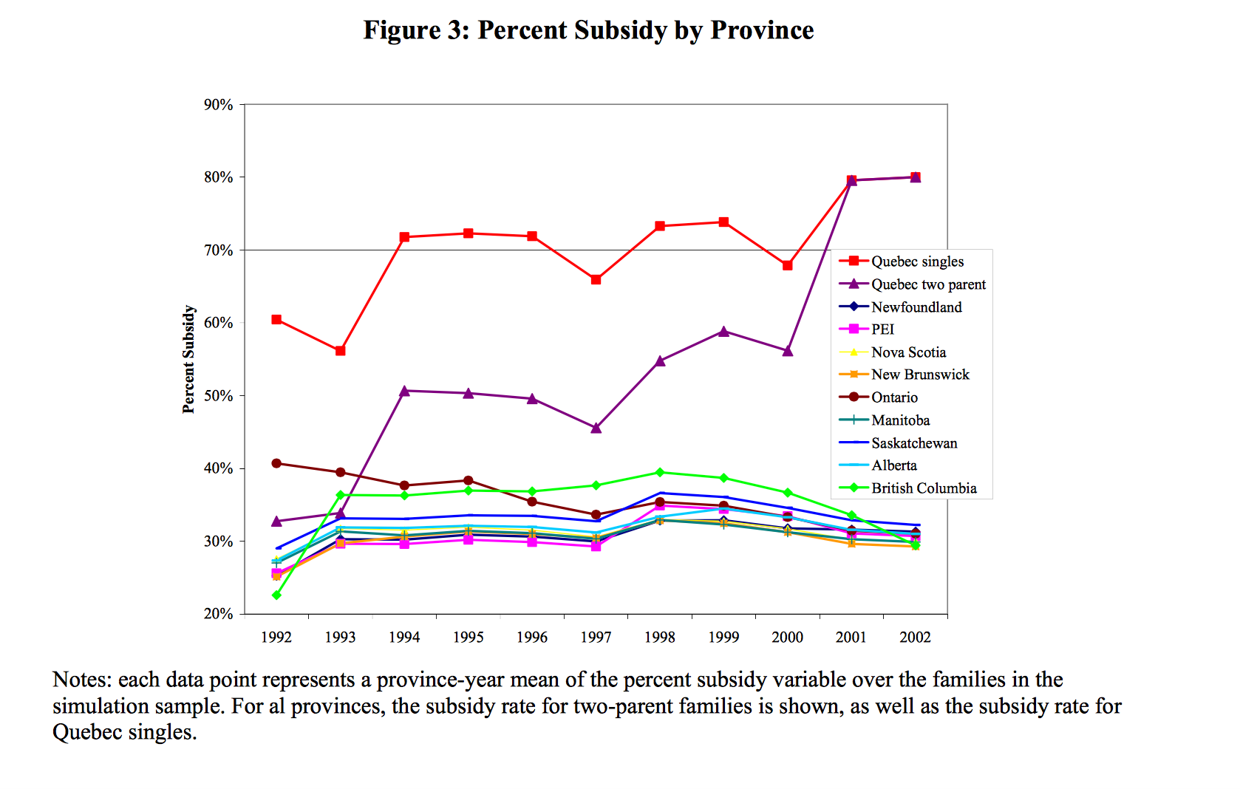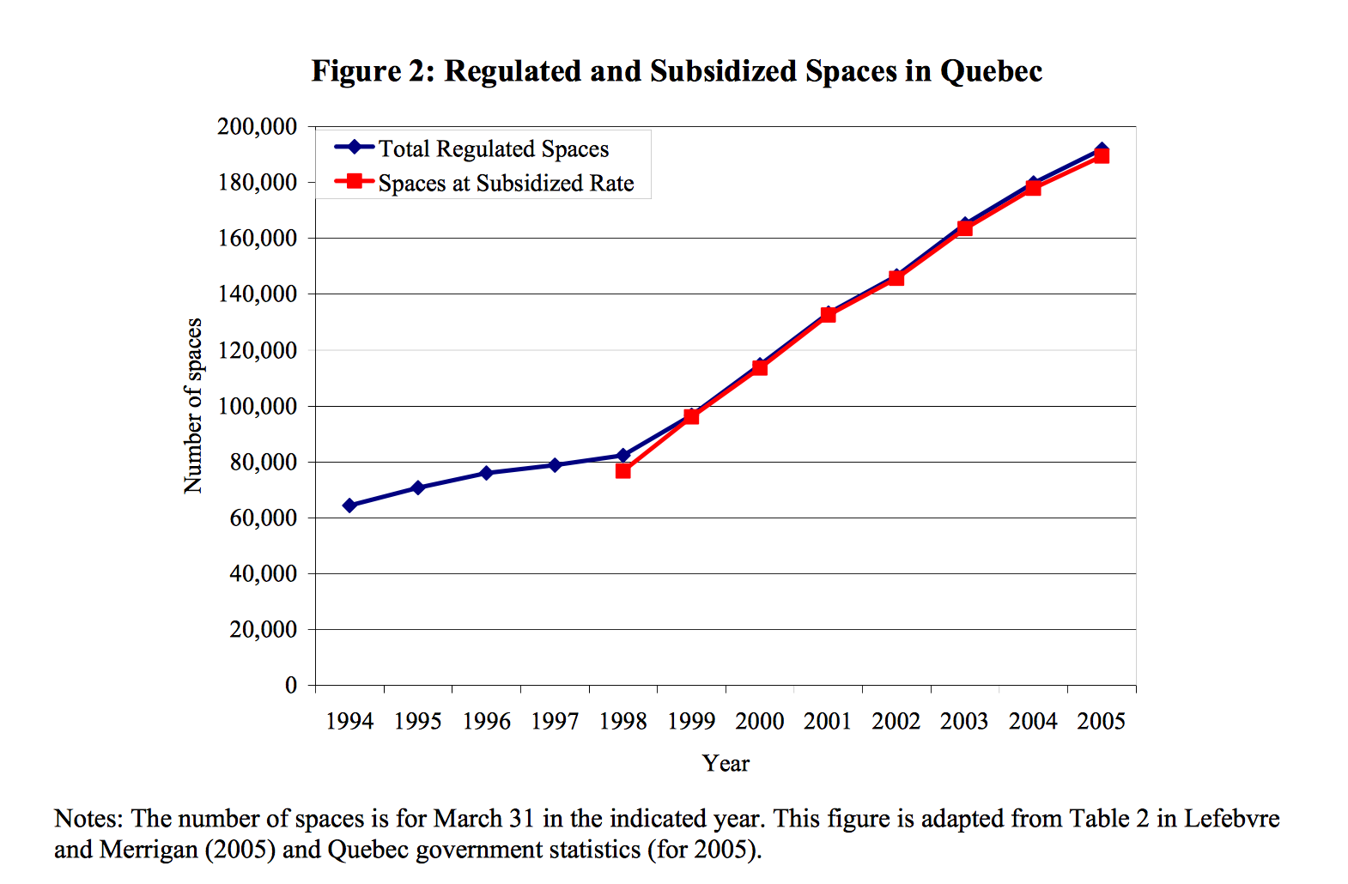

Figure 1: Percent subsidy by province
Source: baker et al., 2008, p. 53

Figure 2: Regulated and subsidized spaces in Quebec
Source: baker et al., 2008, p. 52

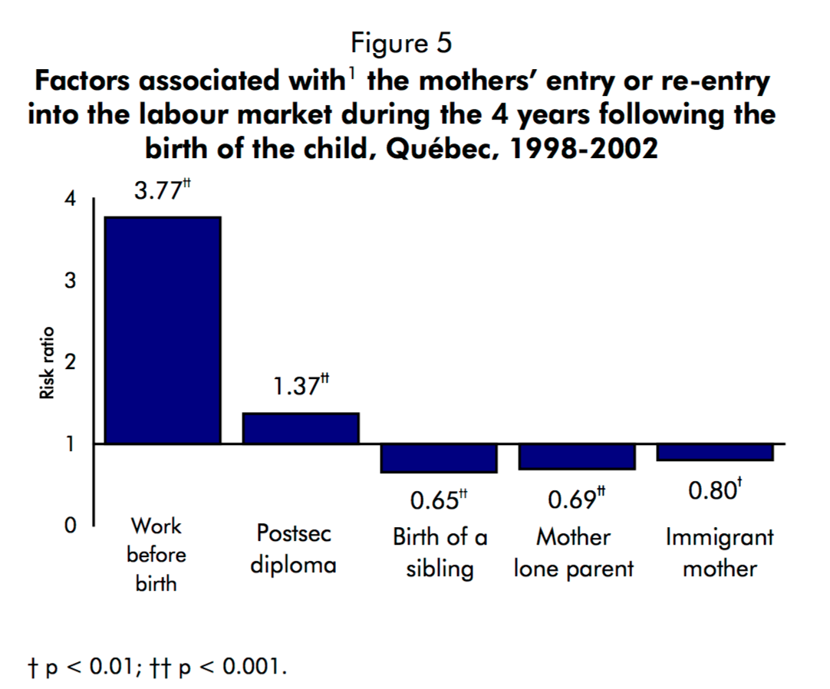
Source: Desrosiers et al 2004, p. 5, fig. 5

Figure 3: Factors associated with mothers’ entry or re-entry into the labour market during the 4 years following the birth of the child, Quebec, 1998-2002

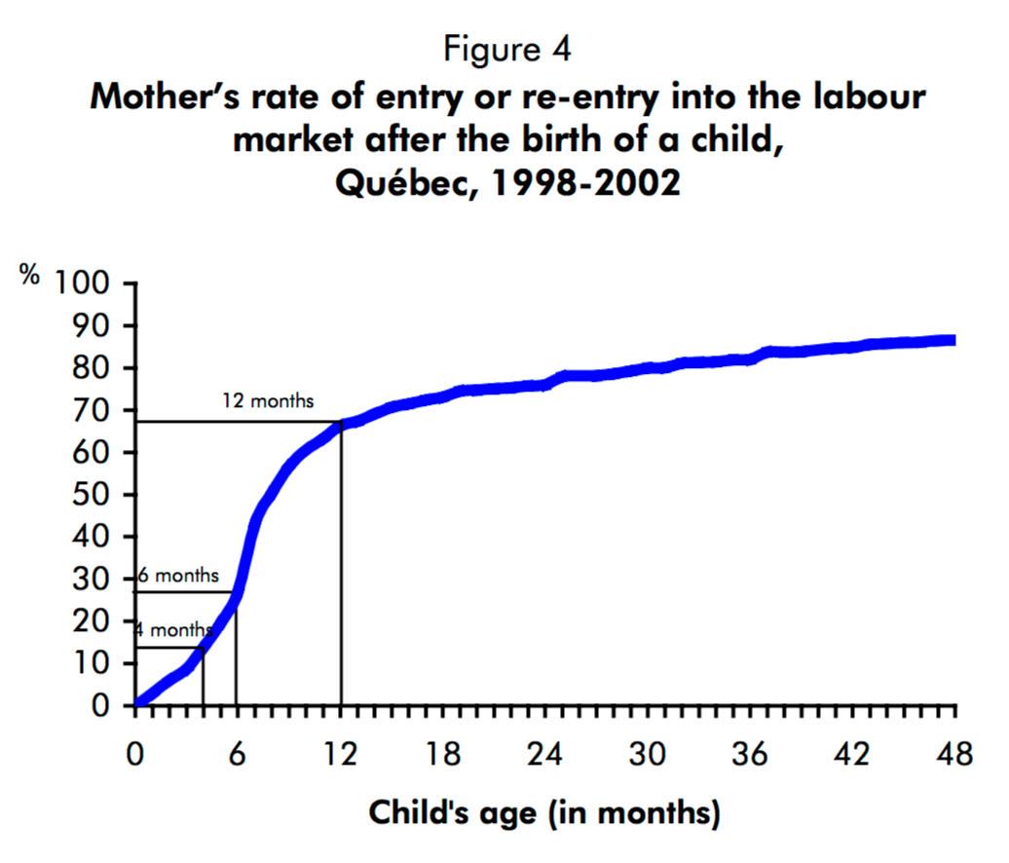

Figure 4: Mothers’ rate of entry or re-entry into the labour market after the birth of the child, Quebec, 1998-2002
Source: Desrosiers et al 2004, p. 5, Fig. 4

As the number of subsidized spaces offered by the government were not yet fully available.
More detail on this study is found in the next section: 2.2 Labour Supply.
This is the model the current paper builds on. The model is explained more fully in the Methodology section.
More than high school includes mothers who are reported by the NLSCY data as having an education ‘beyond high school’ and/or have a ‘college/trade or university degree.’
Occupational skills are ‘the type of skills required in jobs women hold’ as defined by Adsera and Ferrer (2014, p. 5).
Frank and Hou (2015) used data from the 2006-to-2012 Labour Force Survey and the 1994-2007 World Values Survey to obtain their results.
The data is explained more thoroughly in the next section: 4.2 Data.
The socioeconomic control variables in the NLSCY database were mostly supressed or very limited, therefore only the mentioned variables above were included from the Lefebvre et al. (2011) paper.
⁹ The number of hours worked by immigrant mothers are given values by NLSCY as: 1, 2, 3, 4, 5 and 6 with 1: less than 10 hours, 2: 10 to 19 hours, 3: 20 to 29 hours, 4: 20 to 39 hours, 5: 40 to 49 hours and 6: more than 50 hours.
The average of the mothers’ working hours is shown in Tables 5A and 5B along with more descriptive statistics.
Many of the socio-economic control variables used by Lefebvre and Merrigan (2008) were suppressed by the NLSCY data base (for example the size of the community).

